Step1: Go to VirtualBox.org and download windows host edition i.e, Type -2 Hypervisor. Then click on start download.

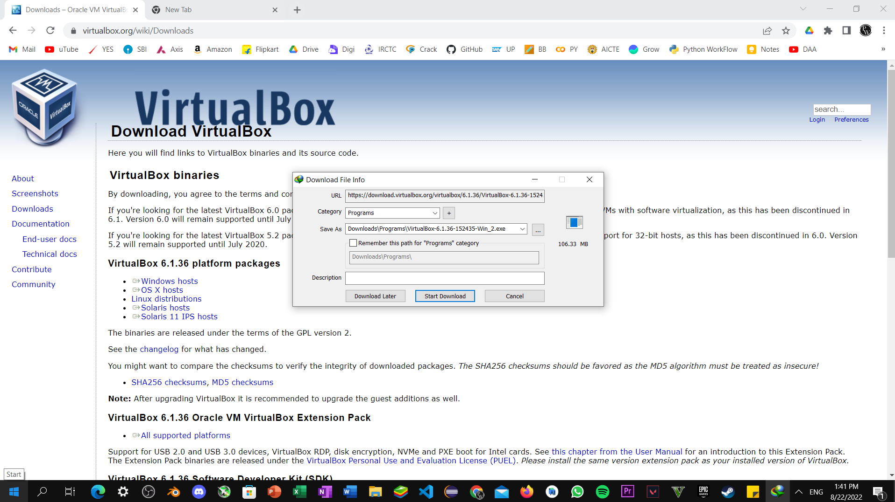

Step2: Double click Virtual Box setup and click on next.

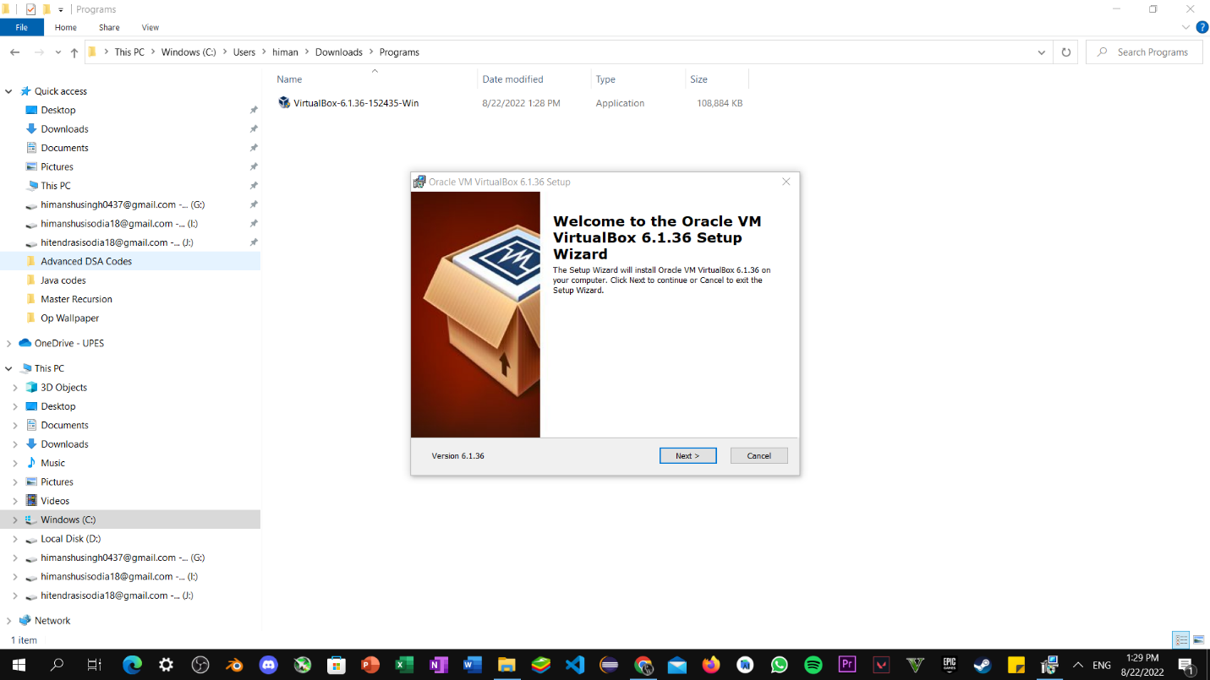

Step3: Now set path and disk management for custom installation, then click on next.

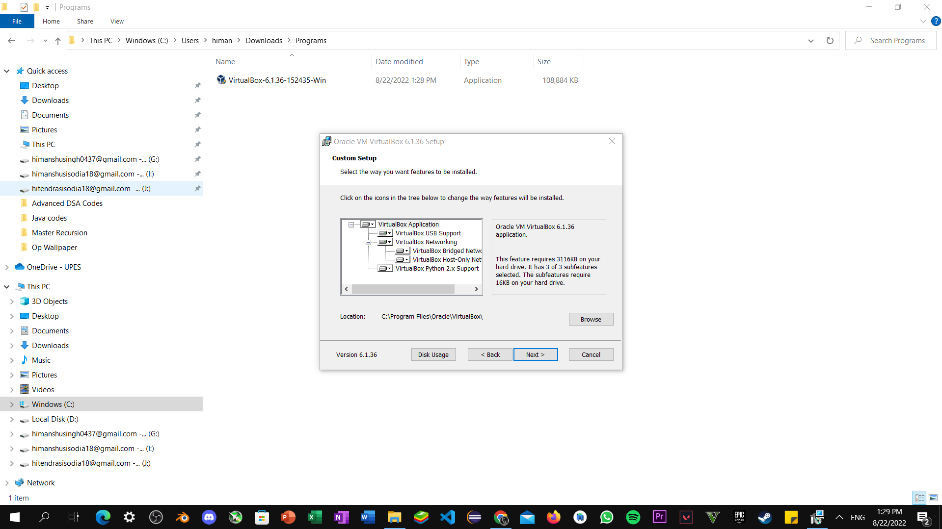

Step4: Now Select the features to be installed Tick on all checkbox provided, click on next.

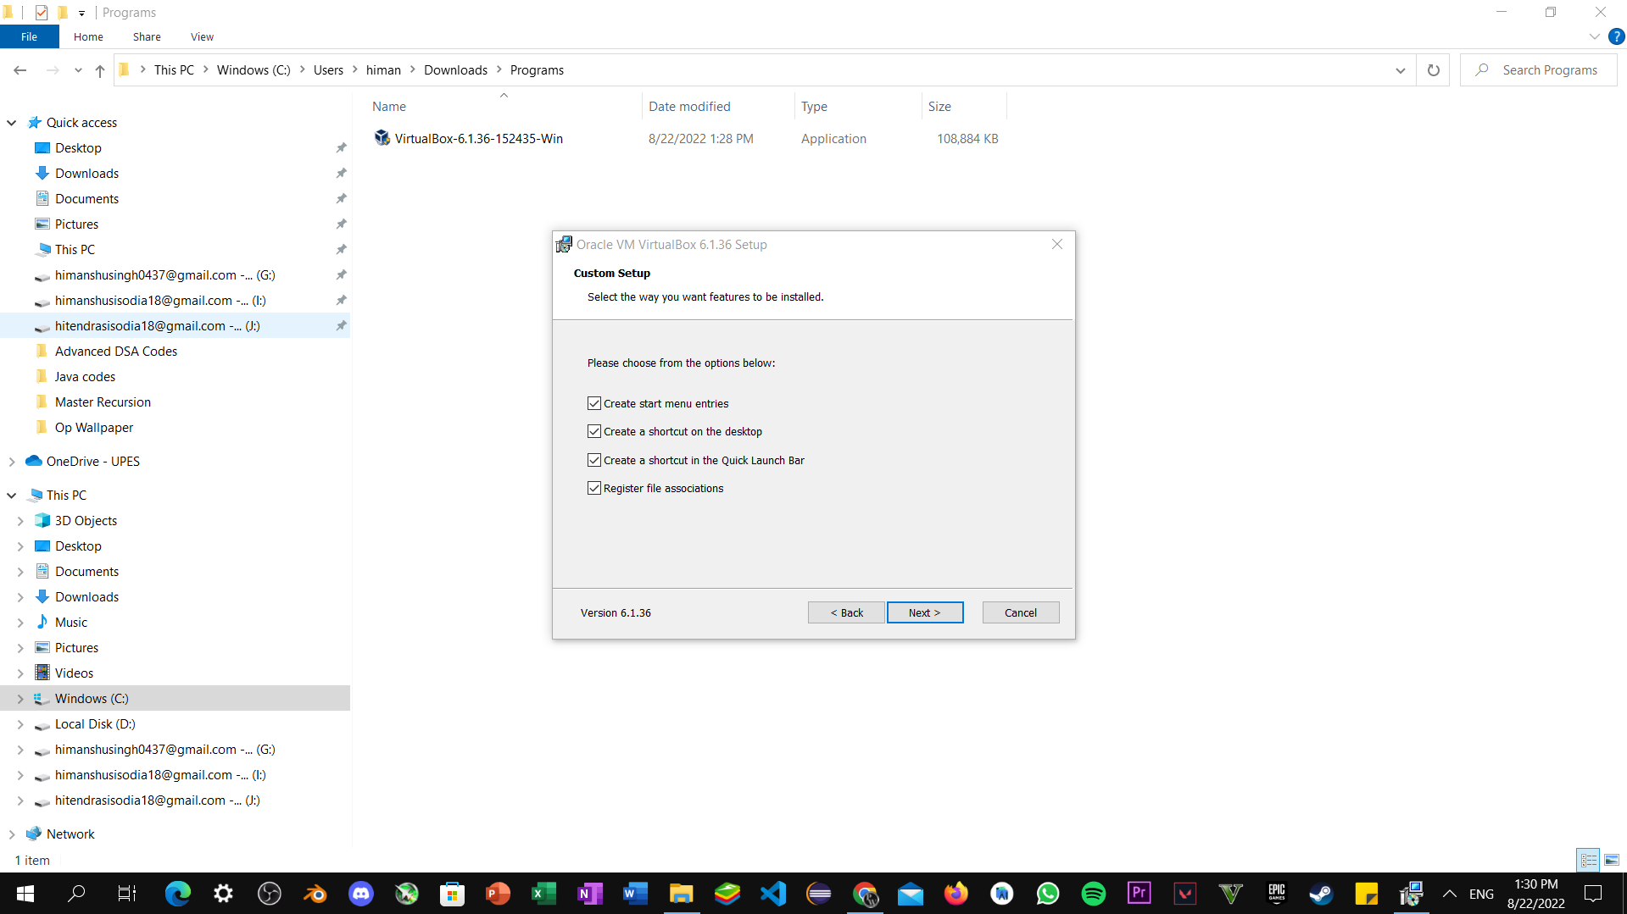

Step5: Now Proceed with installation and click on Yes.

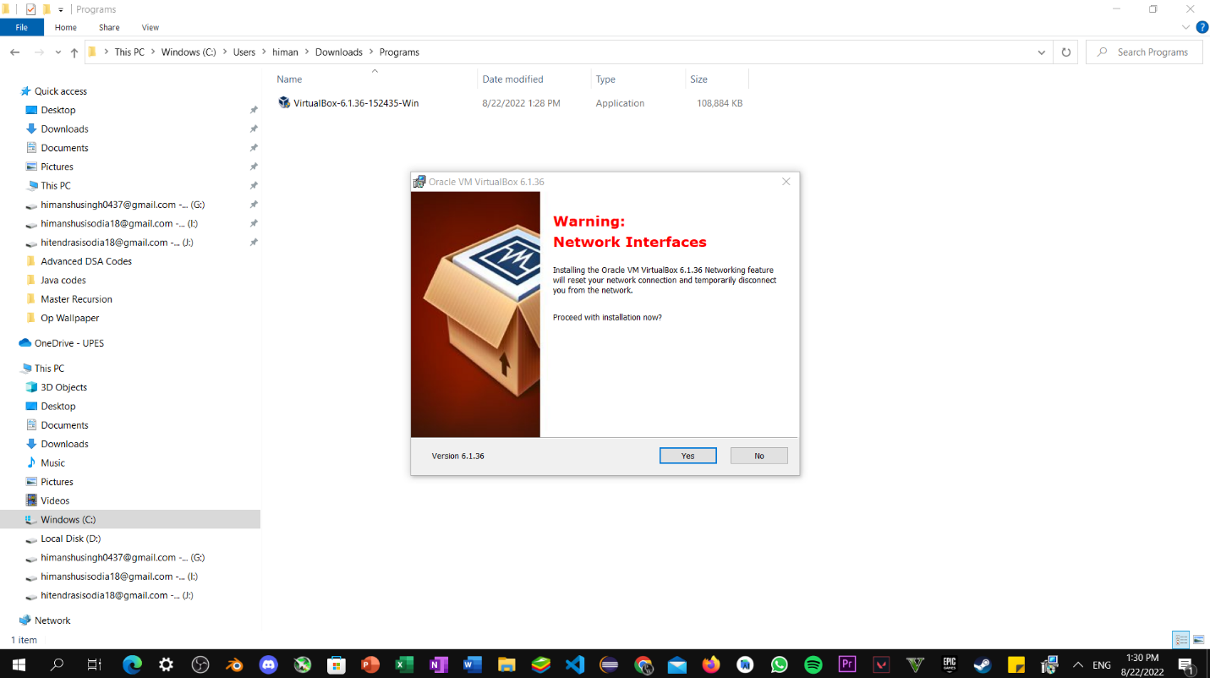

Step6: Now wait till installation completed.

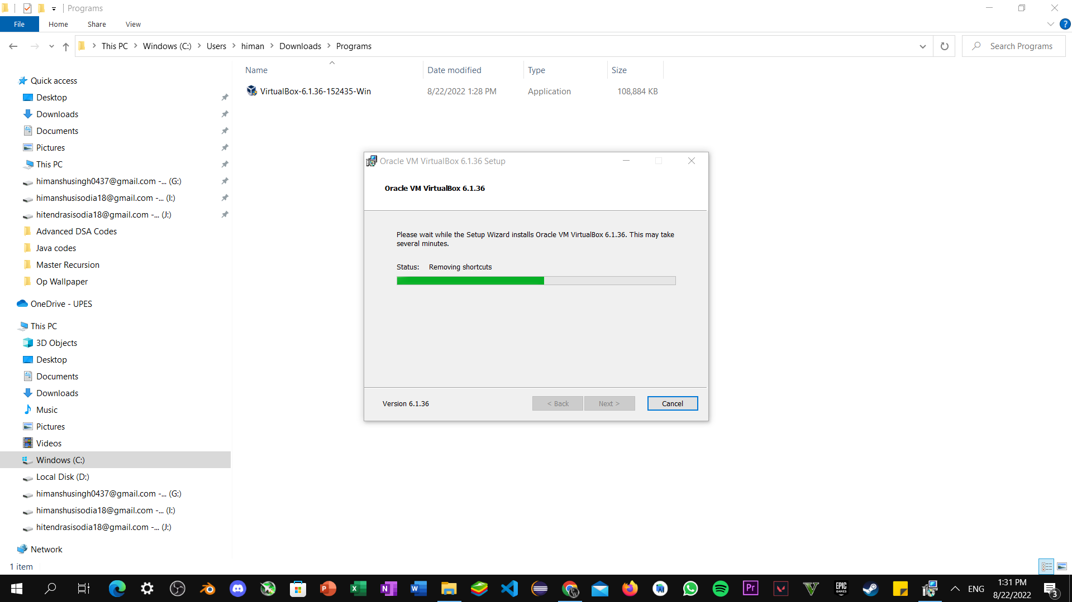

Step7: Once, the installation completed click on launch VirtualBox aster installation and then finish.

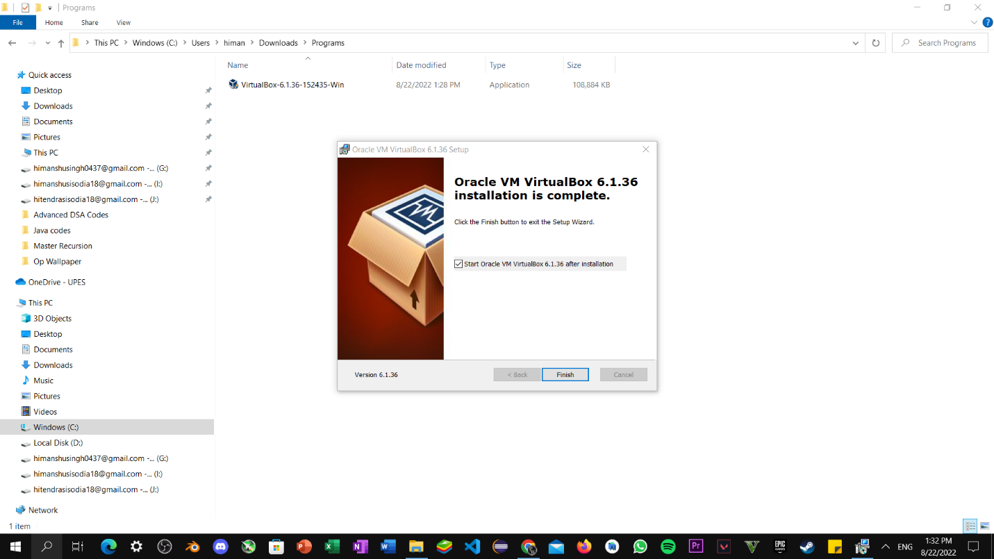

Step8: Now double click on the desktop icon and execute it.

